React.js Component Creation

Name :Chinnapureddy Anji Reddy

MailId: chinnapureddyanjireddy2@gmail.com

Phn no:9505855422

Roll N0 : 20HU1A0418

College Name : Chebrolu engineering college

**source code :**

**CARD COMPONENT :**

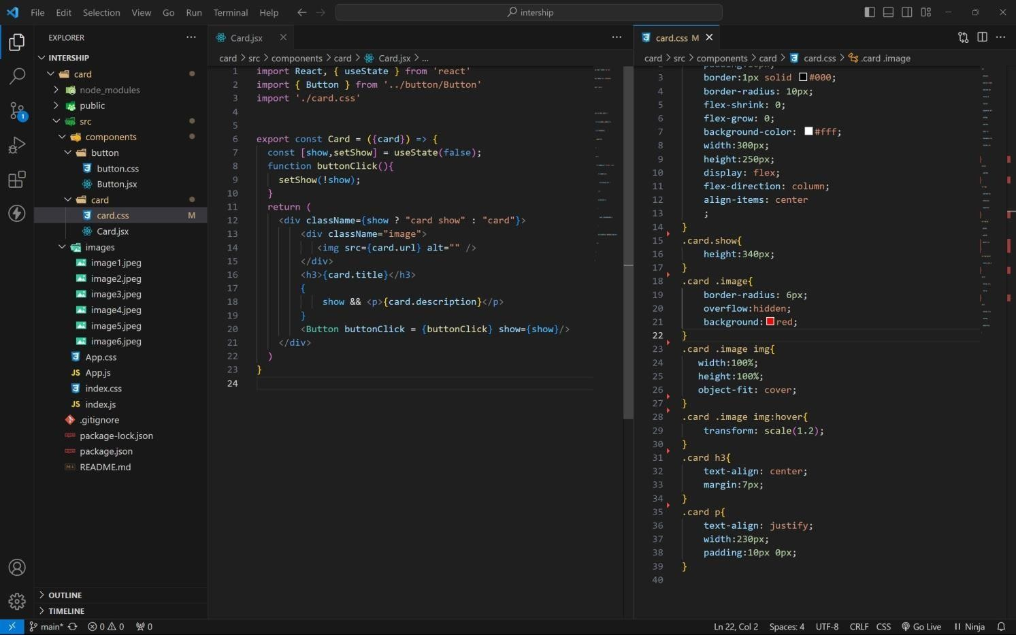

**BUTTON COMPONENT :**

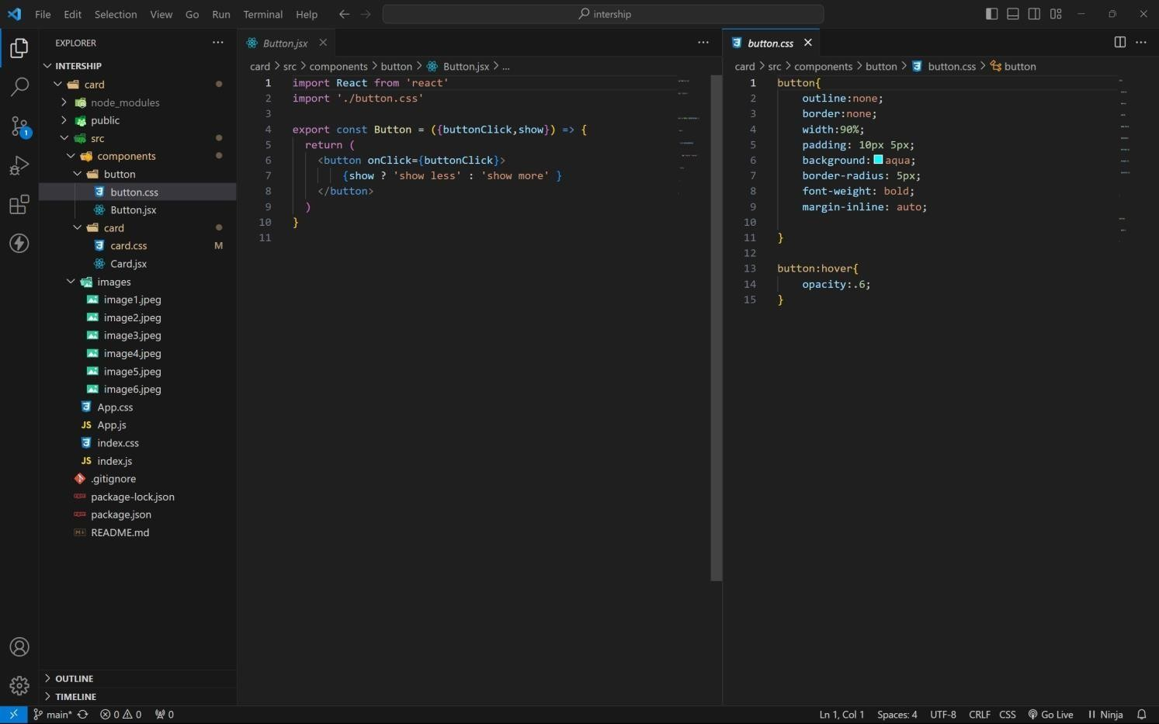

**APP COMPONENT :**

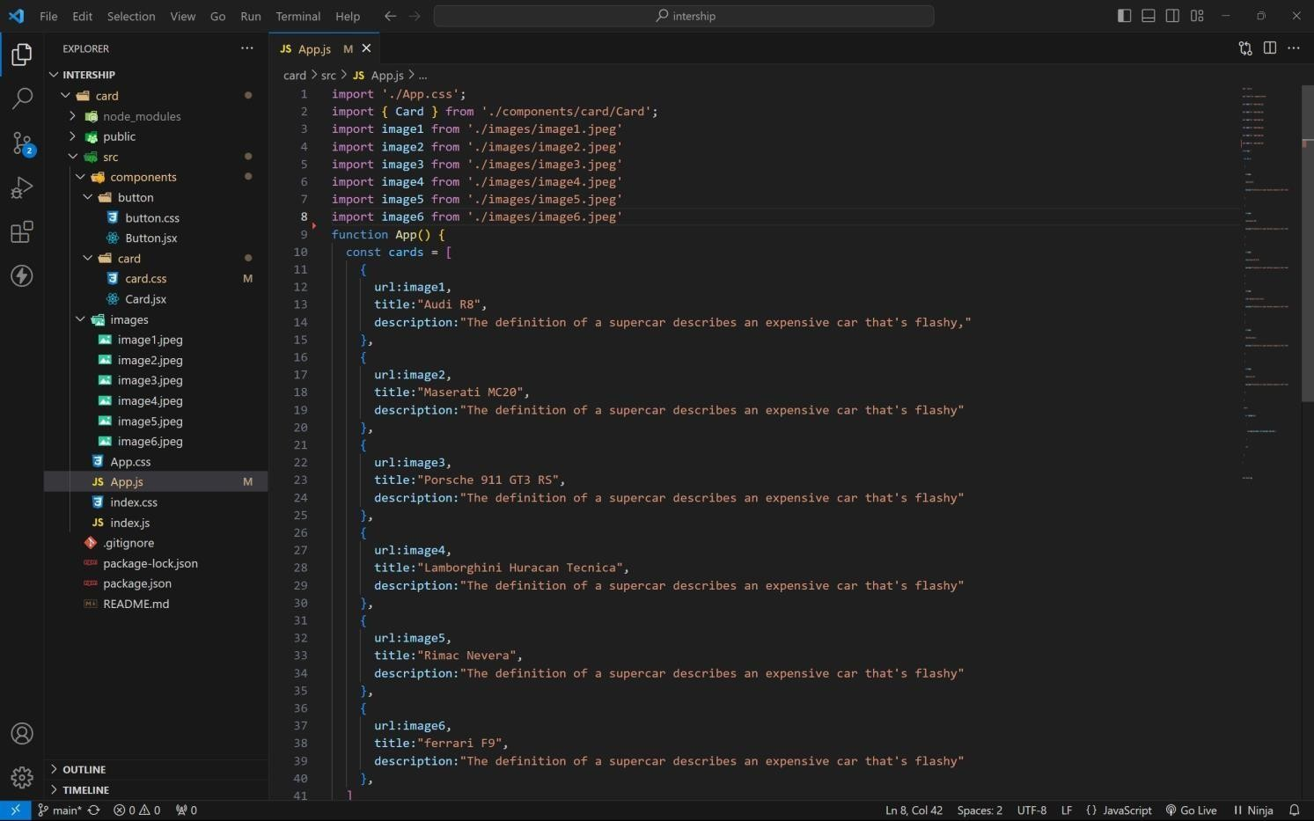

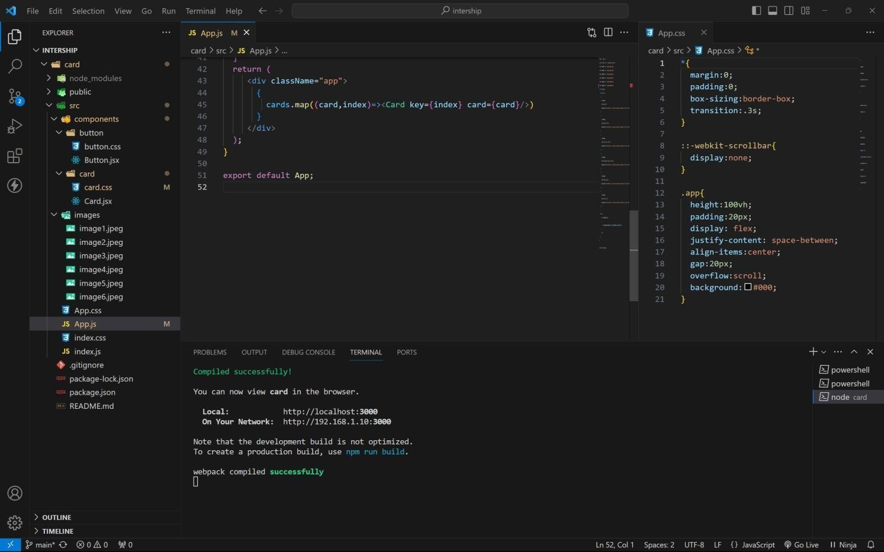

approach :

1. **. initially taking an array of objects like below**

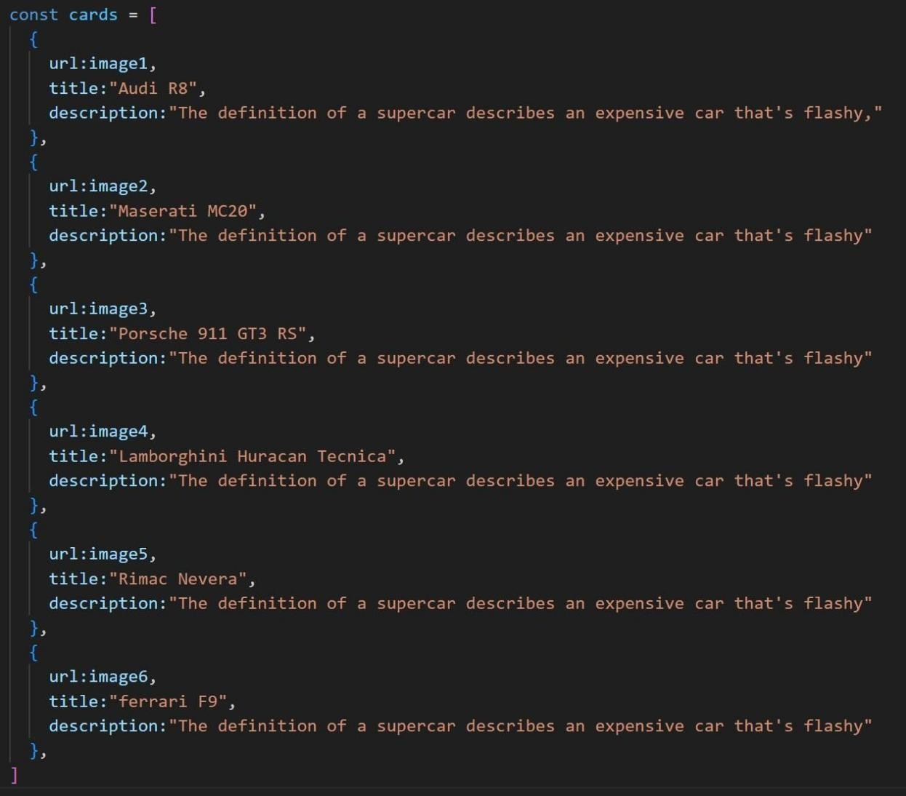

1. **. Passing this card array to child (card component) of App component by using props;**
2. **. getting data as argument like {card} in card component.**
3. **. in card component i use one state [show, setShow] to get extra info as description.**
4. **. When we click the button then show becomes true by assigning setShow (!show) .**

**OUTPUT :**

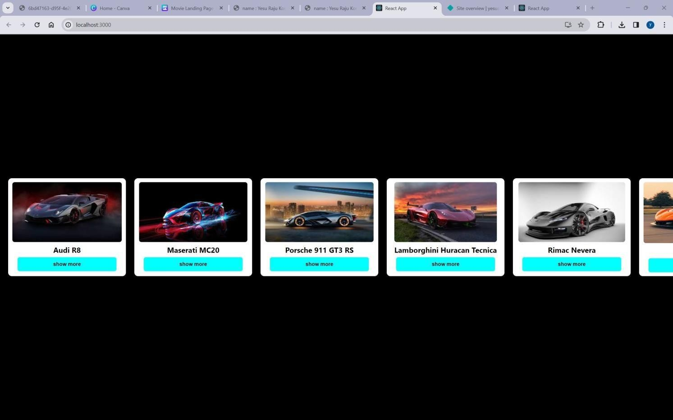

**AFTER BUTTON CLICKS :**

